# **Phase 1: Problem Understanding & Industry Analysis**

## **Requirement Gathering**

The Urban Issue Management System is designed to streamline and automate the process of reporting, tracking, and resolving urban infrastructure issues (such as potholes, streetlight outages, garbage problems, playground maintenance, and traffic signal malfunctions). The primary goal is to provide a responsive, transparent, and efficient mechanism for citizens to report problems, for staff to manage and resolve them, and for supervisors and city management to monitor performance and trends.

Key requirements identified include:

* Citizens need a simple and accessible way to submit urban issues, specifying details such as location, type, and description.
* Each issue must be routed to the appropriate department for resolution based on type and location.
* Staff and supervisors require a centralized platform to track the progress of each reported issue.
* Automated assignment of priority and escalation for urgent or critical issues is essential.
* Timely notifications and communications (e.g., email alerts) are required for both citizens and staff.
* The system must support reporting and analytics for operational oversight and continuous improvement.

## **Stakeholder Analysis**

The main stakeholders for this project are:

* Citizens: Individuals who identify and report urban issues within the city limits. Their experience should be straightforward and transparent, with notification at each major status change.
* City Staff: Employees responsible for investigating and resolving reported issues. This includes field workers, department representatives, and supervisors.
* Supervisors/Managers: Oversee department performance, approve certain issues (especially urgent or costly ones), and manage escalations.
* City Management: Responsible for oversight, policy, and resource allocation, requiring dashboards and analytics.
* IT/Admin Team: Maintains the system, adapts processes, and manages integrations with other city systems.

Understanding the needs and workflows of each group is essential to the solution’s success.

## **Business Process Mapping**

The current (as-is) process is typically manual or semi-automated, involving phone calls, paper forms, or siloed apps. Issues can be lost, delayed, or tracked inefficiently. The proposed (to-be) process, enabled by Salesforce, is as follows:

1. Citizen submits a new urban issue via a portal or mobile app.
2. The system captures details, assigns a unique issue number, and automatically routes it to the relevant department based on the type and location.
3. Priority is automatically set according to predefined rules (e.g., urgent for main roads or hazardous locations).
4. Staff receive notification and a task for follow-up.
5. Supervisors are notified for approval if the issue is urgent or high-cost.
6. Issue status updates are communicated back to the citizen.
7. The system provides real-time dashboards and reports for management oversight.

This streamlined process reduces delays, increases accountability, and enhances citizen satisfaction.

## **Industry-Specific Use Case Analysis**

Municipalities worldwide face similar challenges in managing urban infrastructure issues. Common pain points include lack of transparency, slow response times, poor communication with citizens, and difficulty in tracking performance. Industry best practices increasingly focus on digital transformation, citizen engagement, mobile accessibility, and data-driven insights.

Our solution draws inspiration from leading smart-city initiatives, leveraging Salesforce’s platform capabilities for automation, notification, and analytics. The system is designed to be scalable, adaptable for future needs (such as IoT sensor integration or AI-driven prioritization), and compliant with municipal data policies.

## **AppExchange Exploration**

To accelerate delivery and maximize value, the project explored relevant Salesforce AppExchange solutions for:

* Citizen service request management
* Field service scheduling and optimization
* GIS and mapping integrations
* Prebuilt dashboards and analytics for city operations

While several apps offer useful features, most are either too generic or lack the specific process customizations required for our city's needs. As a result, a custom Salesforce implementation, with selective use of AppExchange components for notifications or mapping, is chosen as the optimal path.

# **PHASE 2 – Org Setup & Configuration (Urban Issue Management System**

## **Company Profile Setup**

The foundational org settings were configured under Setup → Company Information → Edit for the Urban Issue Management System.

* Name: Urban Issue Management System
* Time Zone: GMT+05:30 Asia/Kolkata
* Locale: English (India)
* Language: English, Currency: INR

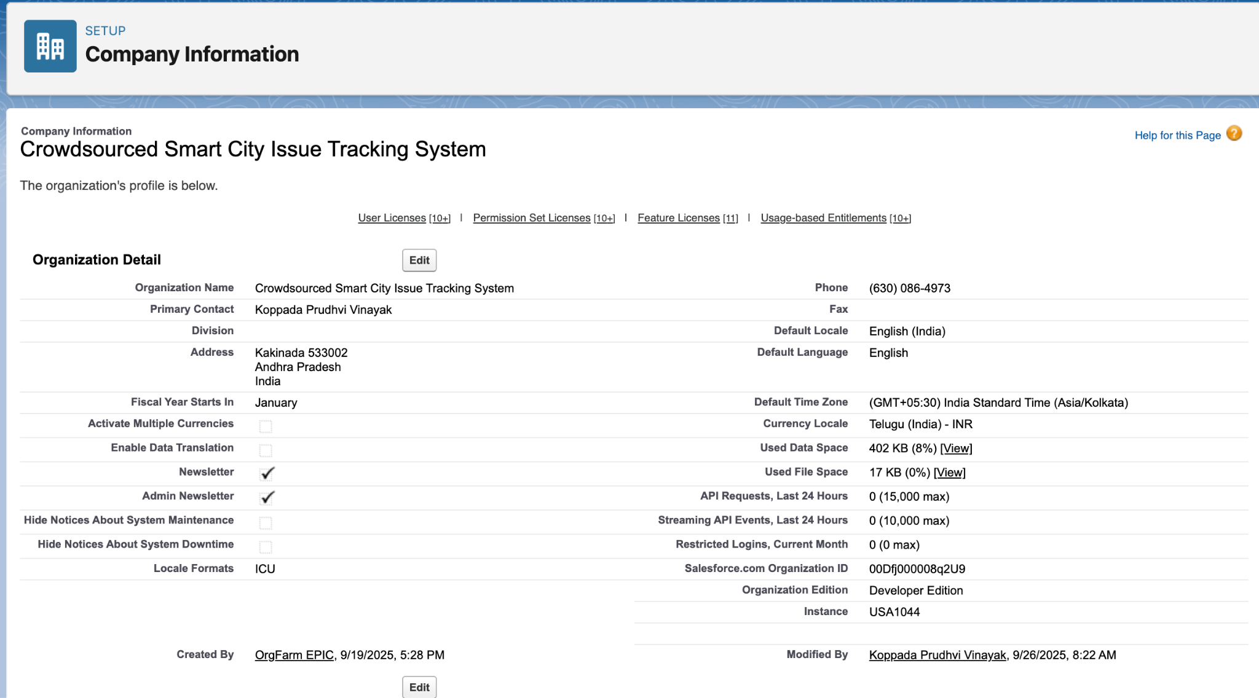

## **Business Hours & Holidays**

Standard business hours were configured to match city/municipal operating hours for case routing and SLA calculations.

* Path: Setup → Business Hours → New
* Name: Urban Issue Standard Hours
* Time Zone: GMT+05:30 Asia/Kolkata
* Working Hours: Monday–Friday, 9:00 AM–6:00 PM
* Holidays: City government holidays and national holidays added for accurate service calculations.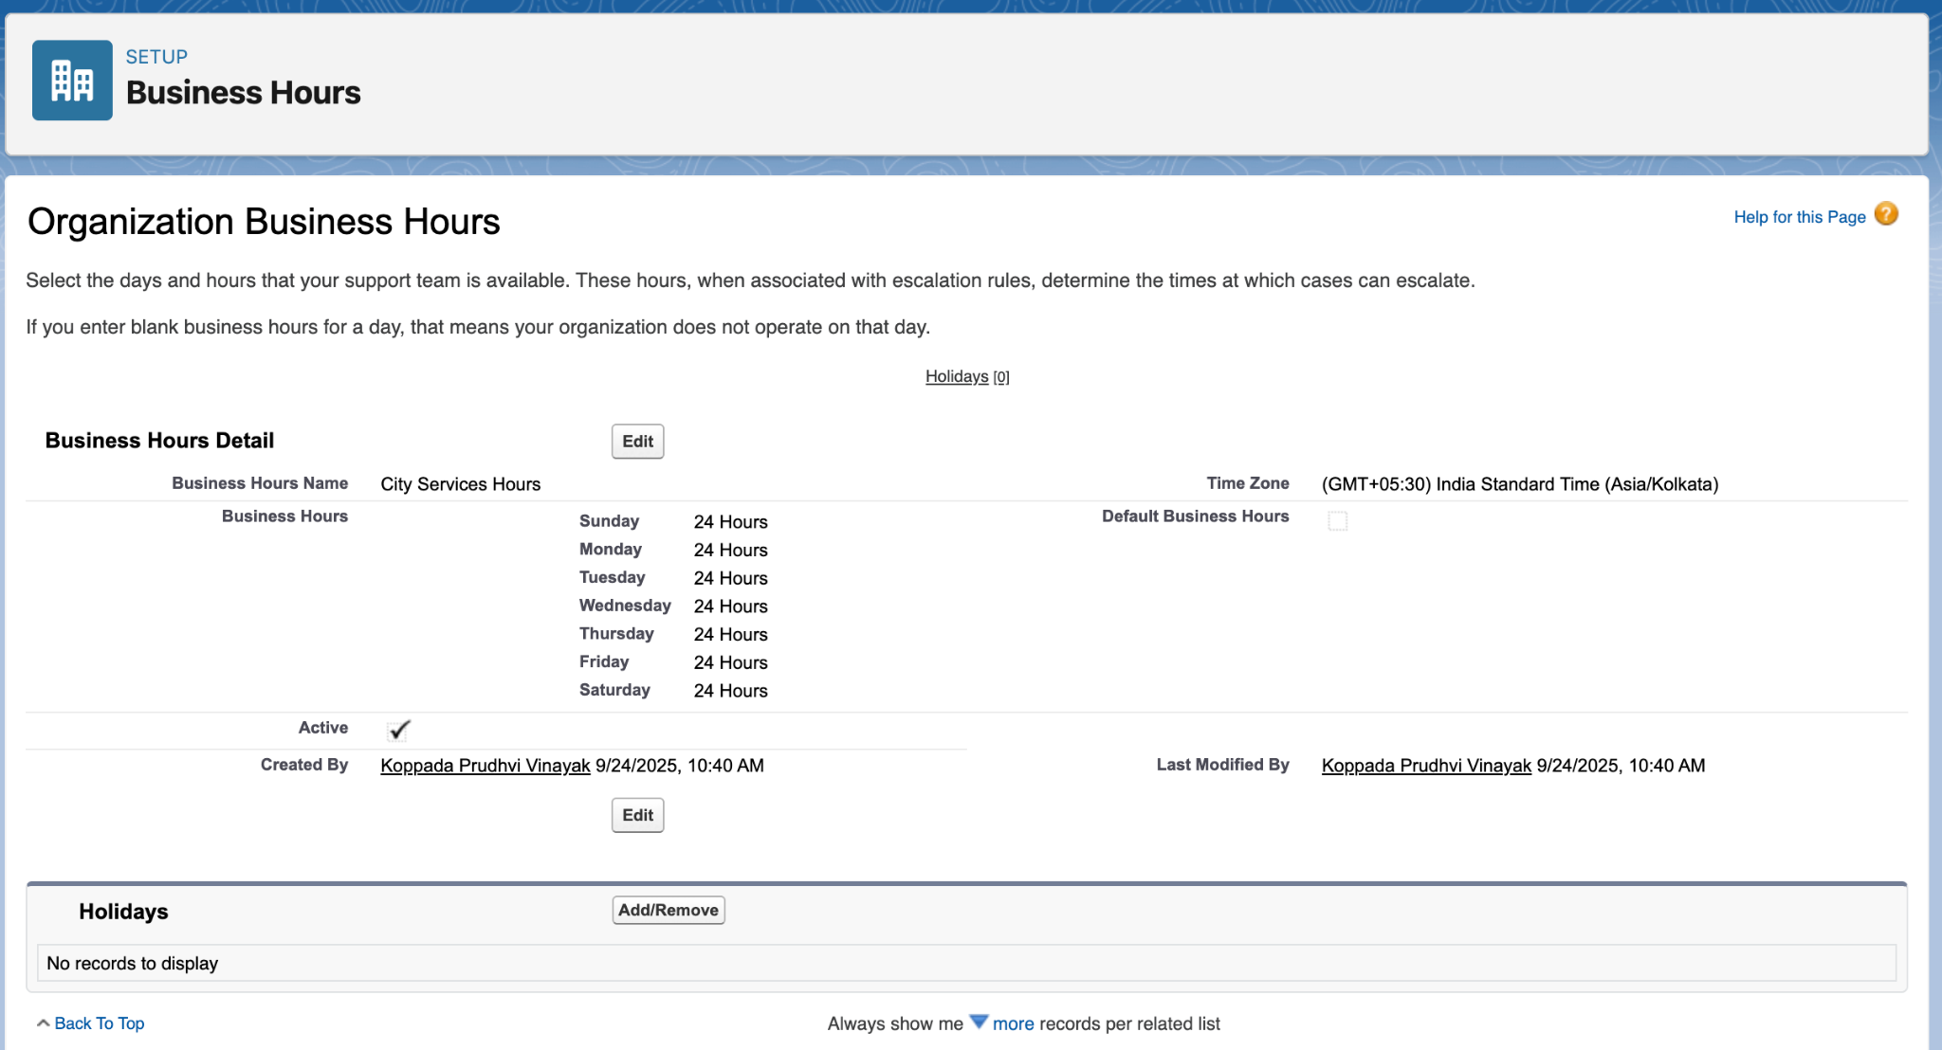

## **Fiscal Year Setup**

The fiscal year was set to standard to align with municipal reporting cycles.

* Path: Setup → Fiscal Year
* Type: Standard Fiscal Year
* Start Month: January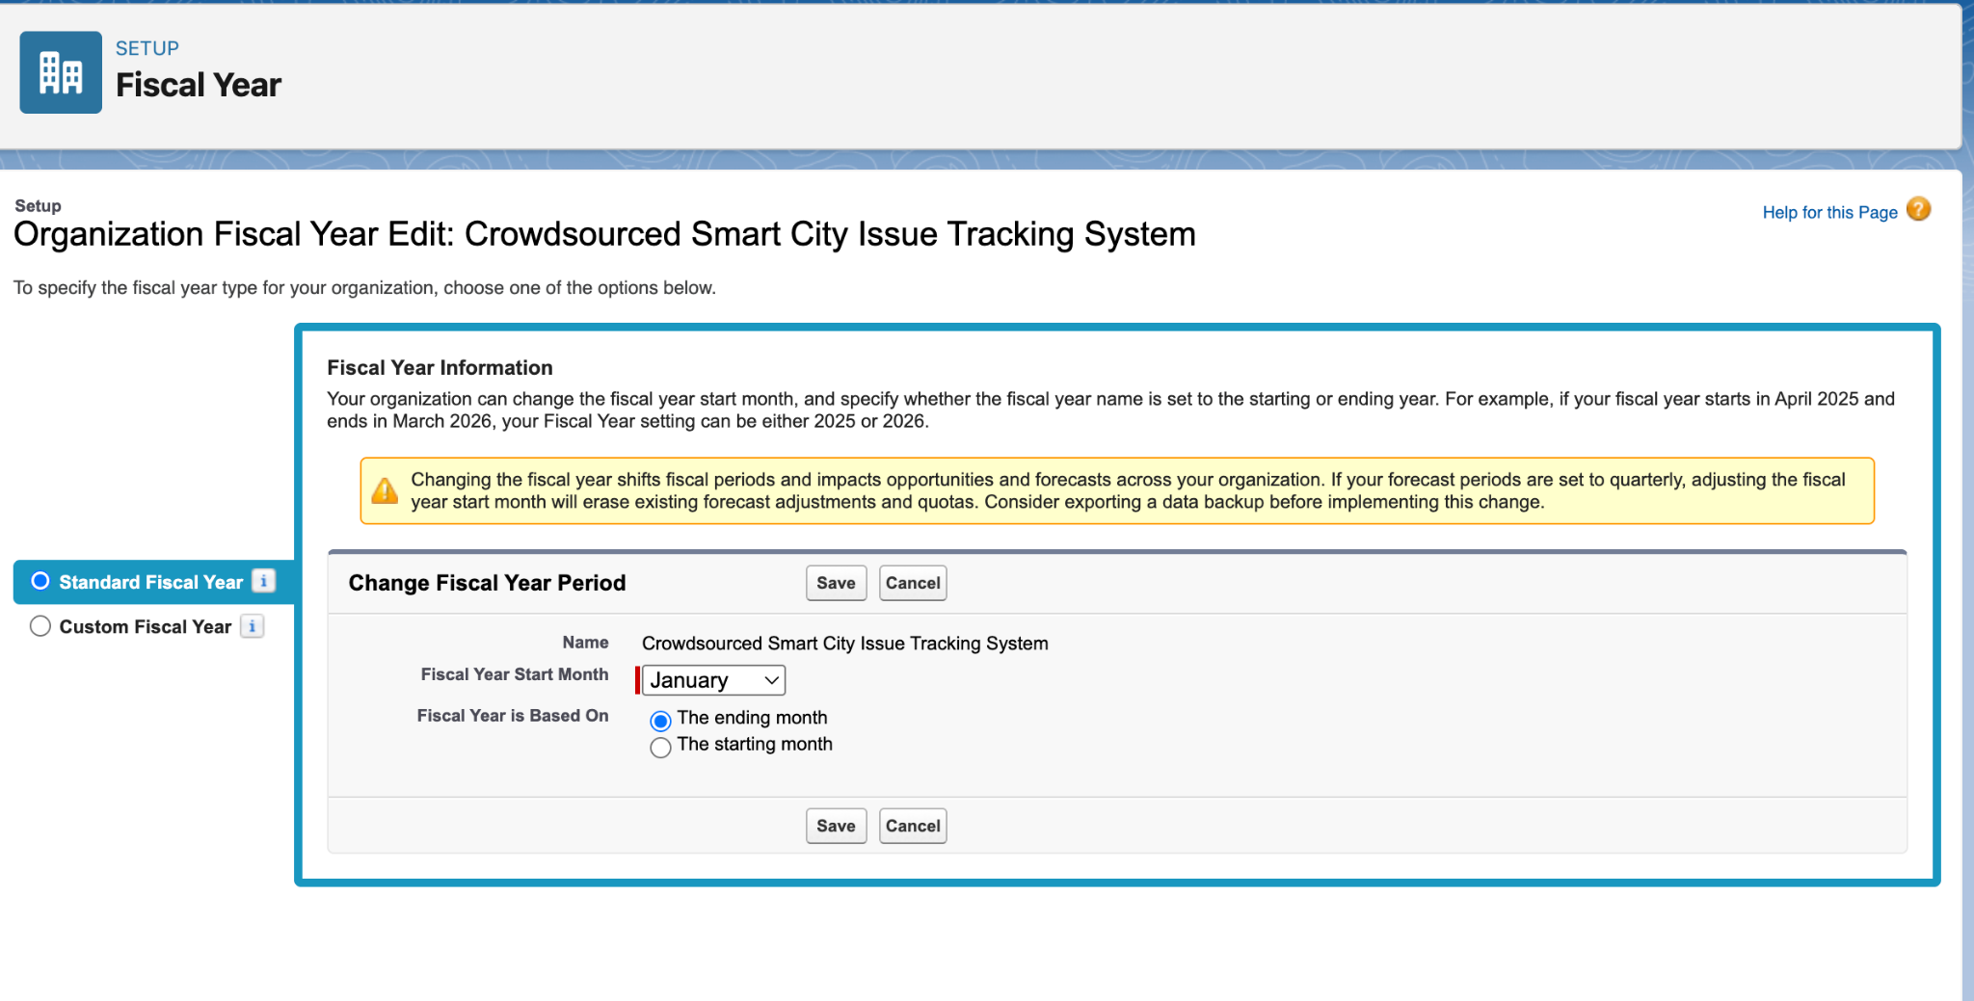

## **User Setup (Profiles, Roles, Permission Sets, Users)**

### ***Profiles***

* *Setup → Users → Profiles.*
* *Cloned "Standard User" profile as Department Staff.*
* *Cloned again as Department Head.*
* *(Optional) Created "Citizen" profile for future Experience Cloud/portal use.*
* *Assigned these profiles to the corresponding users.*

**

### ***Roles***

* *Setup → Users → Roles.*
* *Created the following hierarchy:*
  + *City Admin (top, reports to CEO)*
  + *Department Head (reports to City Admin)*
  + *Department Staff (reports to Department Head)*
* *Assigned these roles to the users created earlier.*

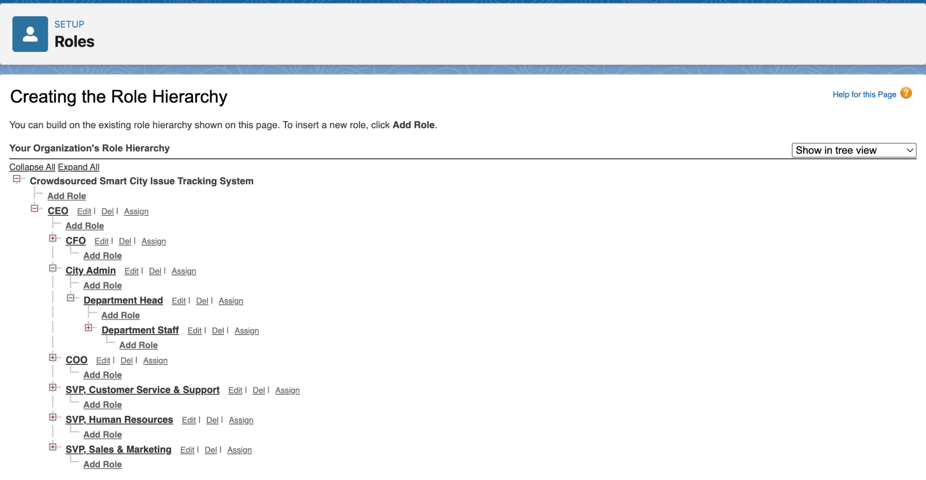

### ***Permission Sets***

* *Setup → Users → Permission Sets.*
* *Created Department Extended Access permission set.*
  + *Checked "Export Reports" and "Run Reports" under System Permissions.*
* *Assigned this permission set to department users (e.g., Ravi Kumar, Sita Sharma).*

### **User Setup & Licenses**

* Setup → Users → Users.
* Created users for:
  + System Administrator (yourself)
  + Department Heads (e.g., Ravi Kumar)
  + Department Staff (e.g., Sita Sharma)
* Assigned “Standard User” or custom profile (created in next step).
* Set role to be assigned after roles were created.

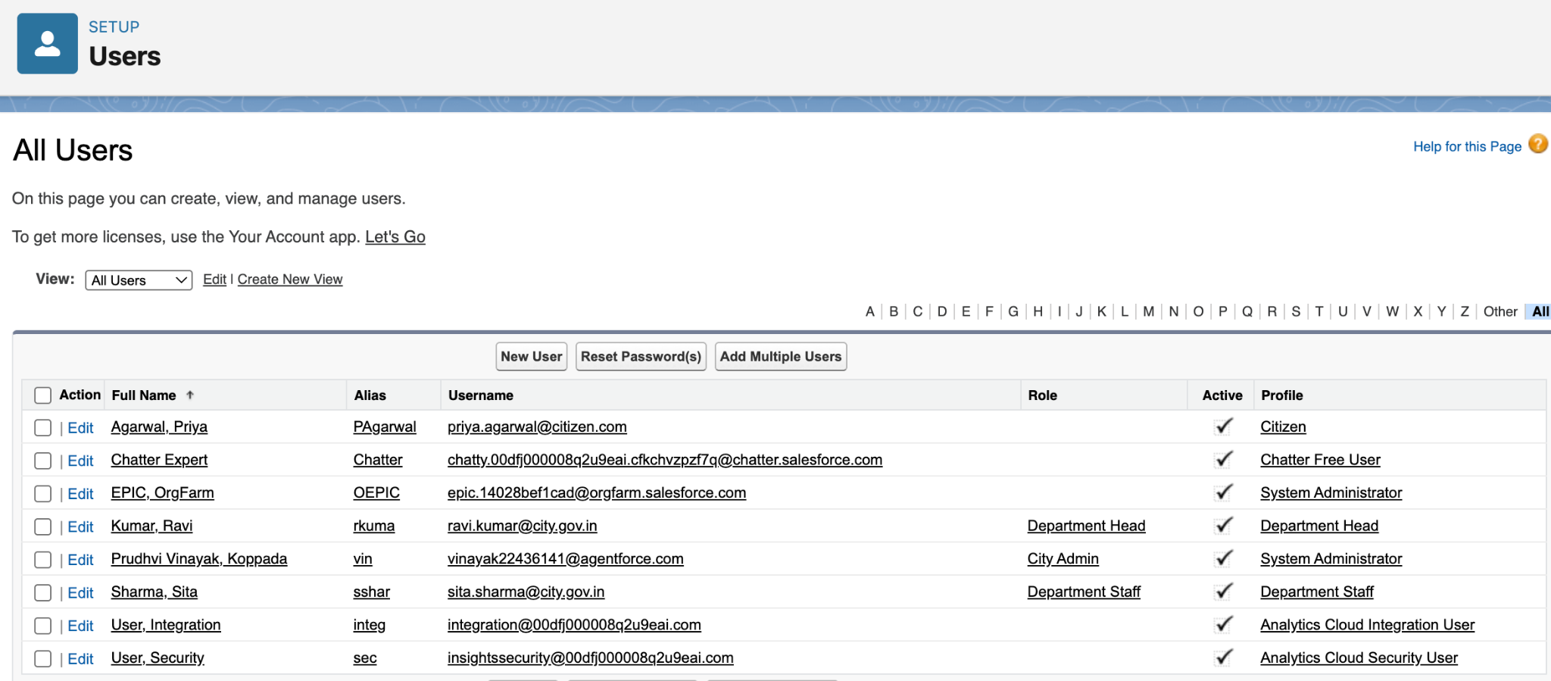

## **Org-Wide Defaults (OWD)**

## Setup → Security → Sharing Settings.

## Set Org-Wide Defaults (Default Internal Access) for:

## Department: Public Read Only

## Urban Issue: Private

## Citizen: Private

## Feedback: Private

## Saved the changes.

## Note: Default External Access left unchanged (no community/portal users yet).

## **Login Access Policies**

## Setup → Security → Login Access Policies.

## Enabled “Administrators Can Log in as Any User”.

## ***Dev Org Setup***

* *All steps performed in a Salesforce Developer Edition org.*

## **Sandbox Usage**

## Developer Edition org used; no sandboxes available.

## Noted in docs that for production, sandboxes and change sets/SFDX would be used for testing/deployment.

# **PHASE 3 – Data Modeling & Relationships (Urban Infrastructure Issue Reporting)**

## **Standard & Custom Objects**

The data model leverages both standard and custom objects to create a scalable, government-centric application.

Standard Objects:

* User: Represents city staff, department heads, and system administrators who manage issues and oversee departments.

Custom Objects:  
Four custom objects form the backbone of the solution:

* Department: Represents each city or municipal department responsible for handling reported issues (e.g., Sanitation, Public Works, Utilities).

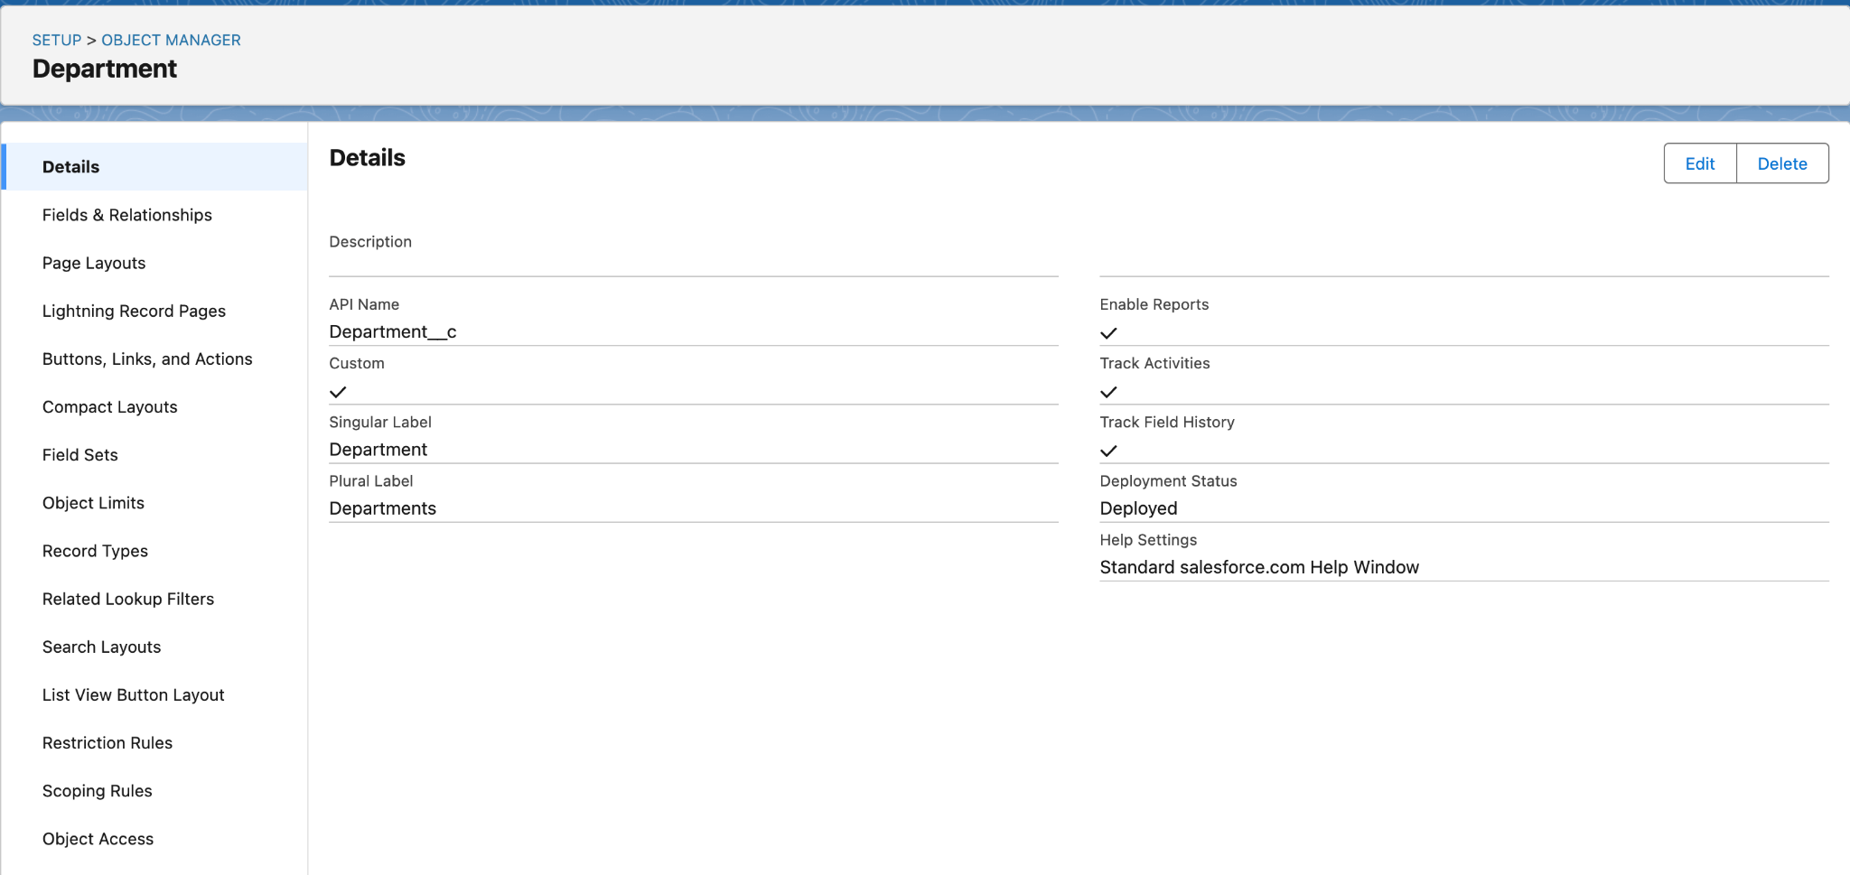

* Urban_Issue: Captures all reported urban issues, including details like status, type, location, and assigned department.

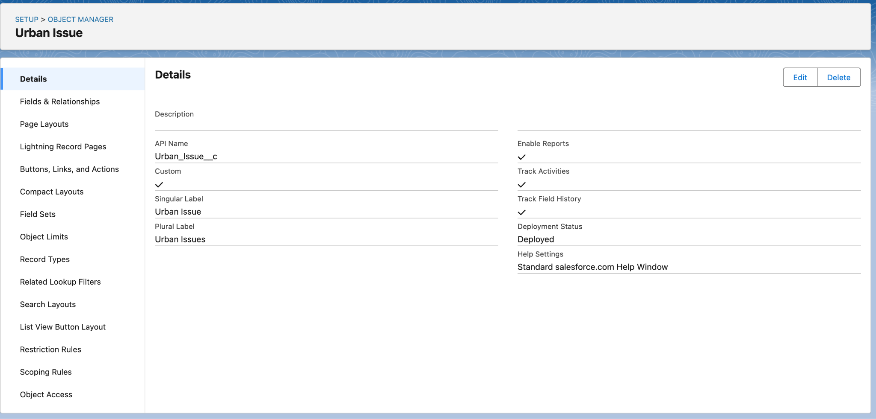

* Citizen: Stores information about citizens who report issues (name, contact details, government ID, etc.).

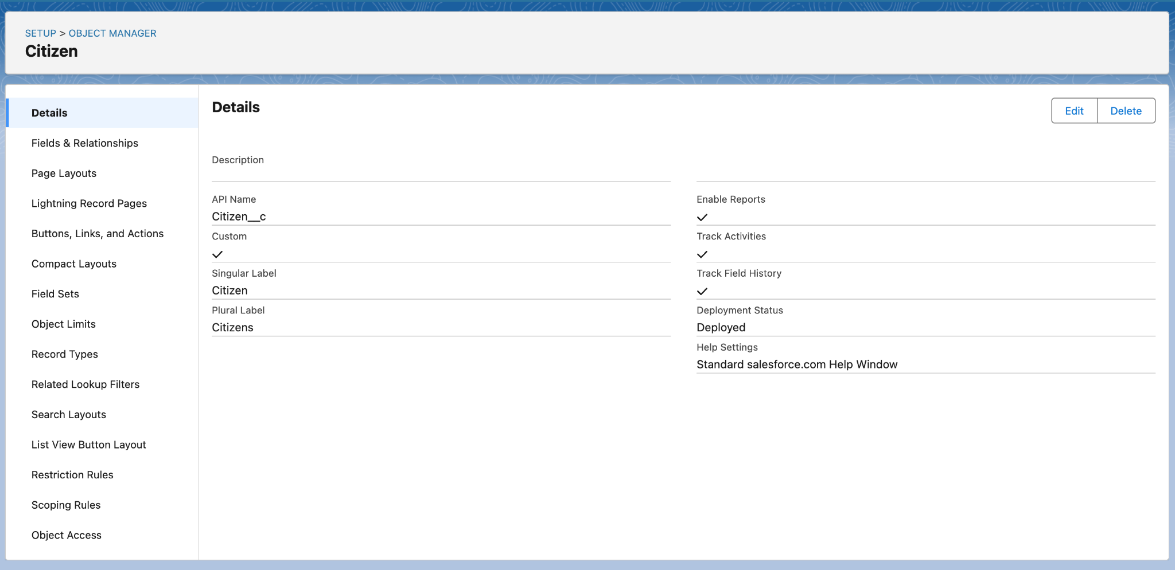

* Feedback: Collects feedback and ratings from citizens about the quality and timeliness of issue resolution.

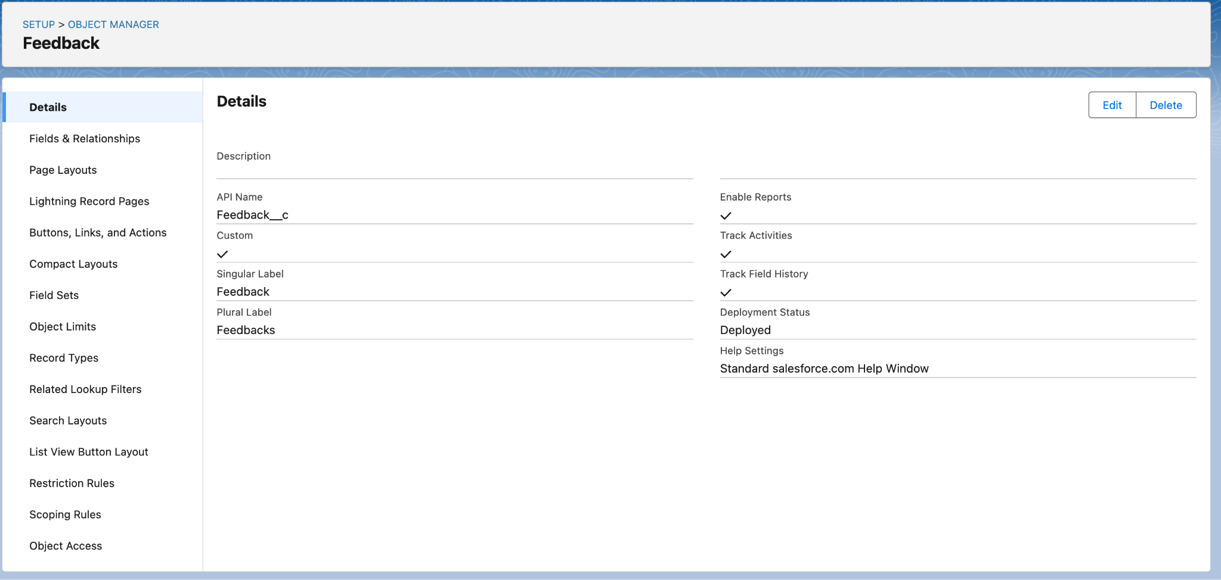

* Staff: Helps to Track the staff information.

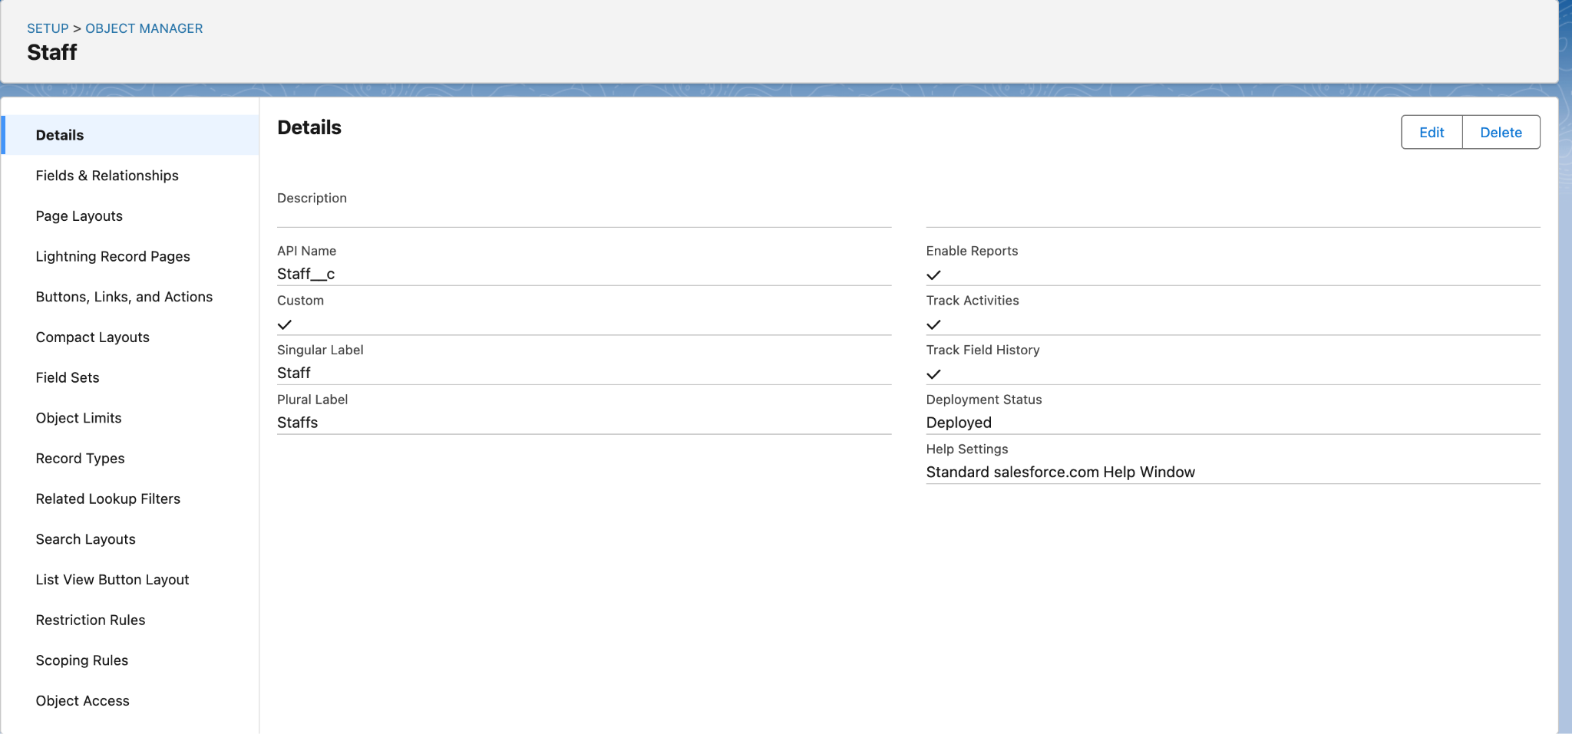

## **Fields & Relationships**

Custom fields capture essential data, and lookup relationships create the necessary links between objects.

Relationships:

* Urban_Issue → Department: Lookup relationship; each urban issue is assigned to a department based on type/location.
* Urban_Issue → Citizen: (Future/optional) Lookup relationship, if issues are to be directly linked to the reporting citizen (not yet implemented).
* Feedback → Citizen: Lookup relationship; feedback is tied to the citizen who submitted it.
* Feedback → Urban_Issue: Lookup relationship; feedback is tied to the resolved urban issue.
* Department → Department Head: Lookup to User; identifies the supervisor/manager for each department.

Custom Fields:

*On Department:*

* Department_Code (Text)
* Department_Email (Email)
* Department_Head (Lookup to User)
* Phone_Number (Phone)

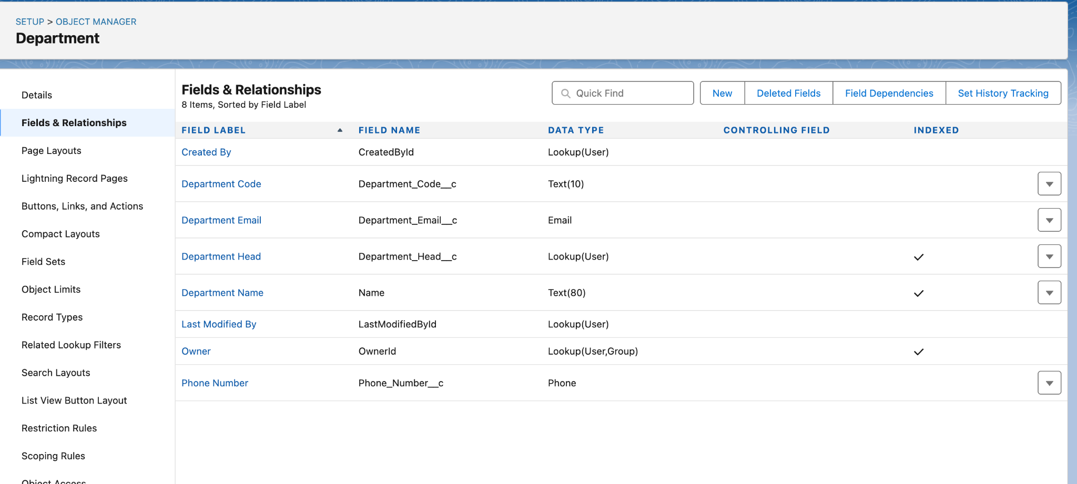

*On Urban_Issue:*

* Issue_Title (Text)
* Description (Long Text Area)
* Location (Text)
* Status (Picklist: New, In Progress, Resolved, Closed)
* Department (Lookup to Department)
* Department_Name (Text, for sharing rule workaround)

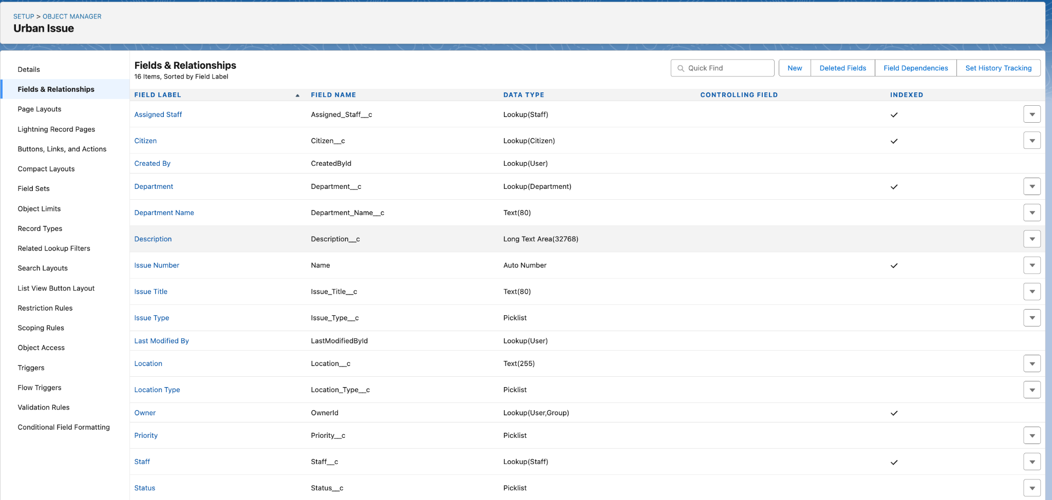

*On Citizen:*

* Email (Email)
* Phone_Number (Phone)
* Address (Text Area)
* Government_ID (Text)

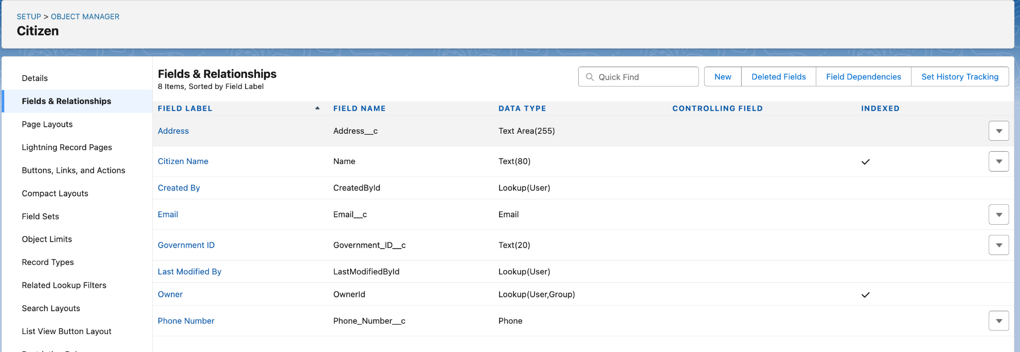

*On Feedback:*

* Feedback_Text (Long Text Area)
* Rating (Picklist: 1, 2, 3, 4, 5)
* Citizen (Lookup to Citizen)
* Urban_Issue (Lookup to Urban_Issue)

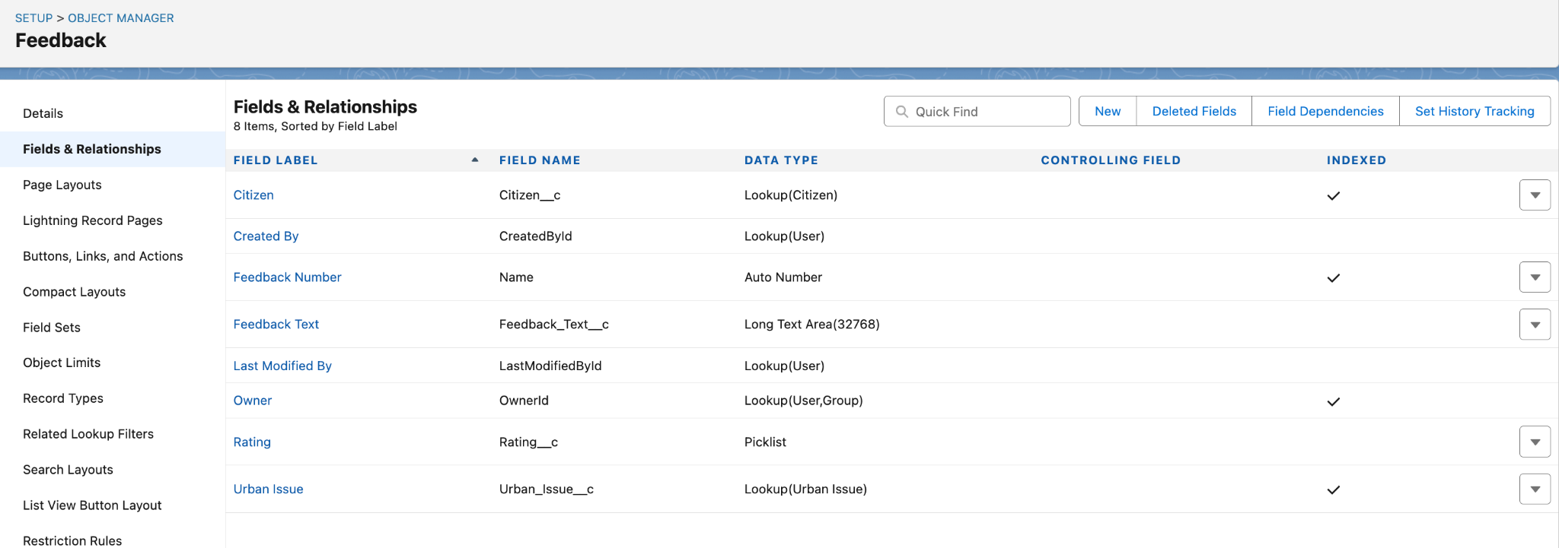

## **User Interface & Layouts**

To ensure a user-friendly and efficient on-screen experience:

Page Layouts:  
A dedicated page layout was created and customized for each custom object (Department, Urban Issue, Citizen, Feedback), organizing fields for easy data entry and review.

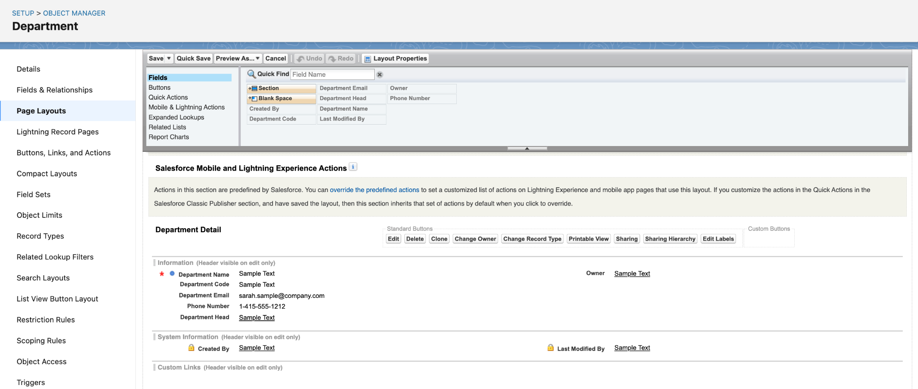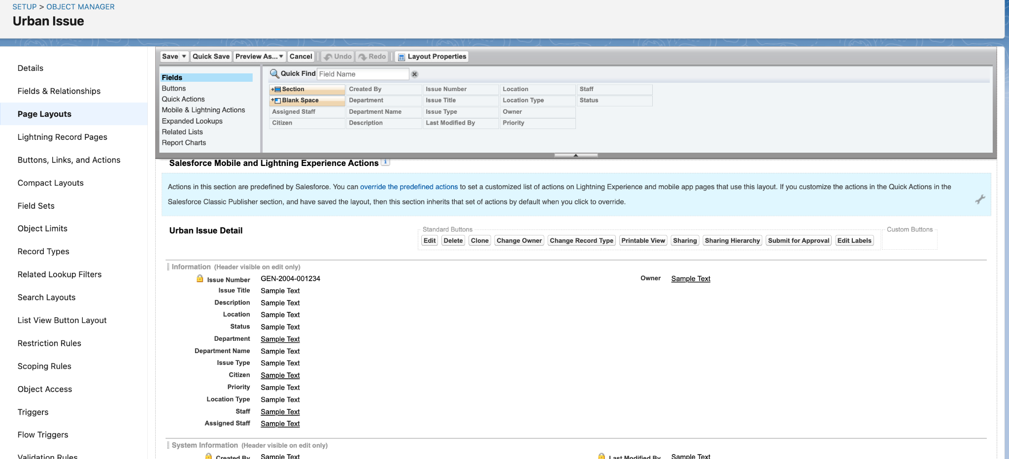

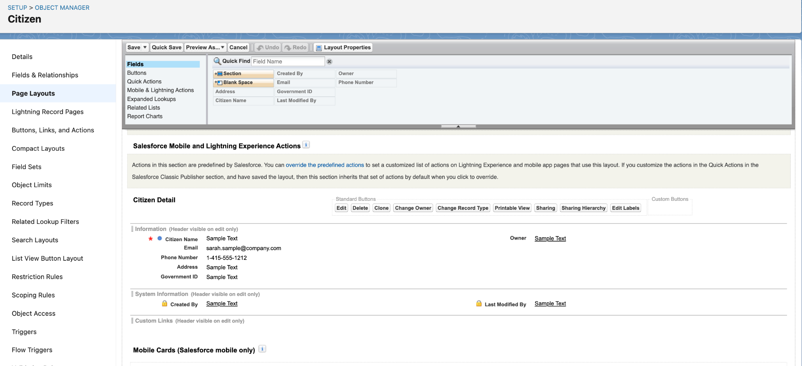

Compact Layouts:  
A compact layout was configured for each custom object to display key fields in the highlights panel and on mobile.

* *Example (Urban_Issue):* Compact layout includes Issue_Title, Status, and Department.

Record Types:  
A single record type is used for each object at this stage.  
(Future enhancement: Add record types to Urban_Issue for different issue categories or reporting sources.)

## **Data Architecture**

Schema Builder:  
The data model was visualized using Schema Builder, clearly showing:

* Department at the center with lookups from Urban_Issue.
* Citizen object connected to Feedback (and optionally Urban_Issue).
* Feedback object with lookups to both Citizen and Urban_Issue.

## 

## 